Built in algorithms

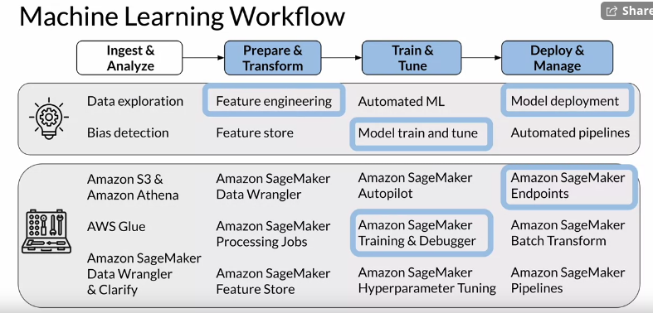
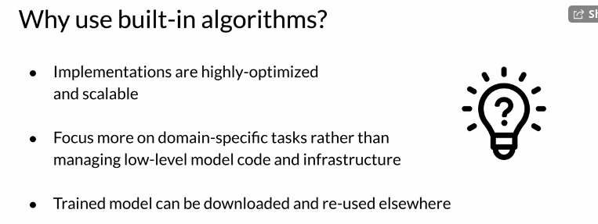
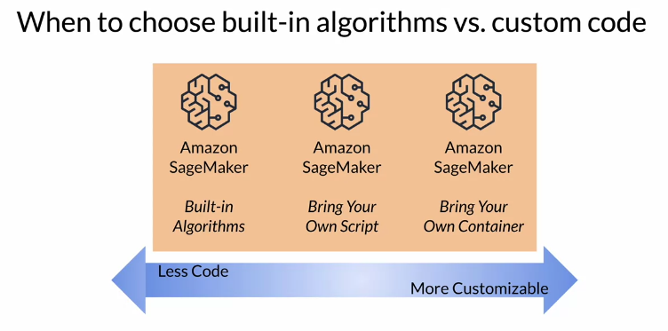

Use cases and algorithms

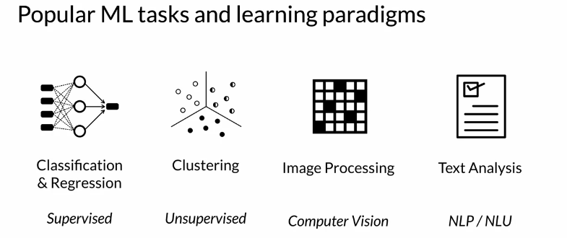
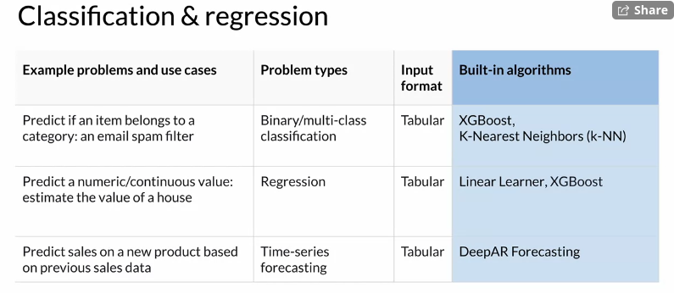
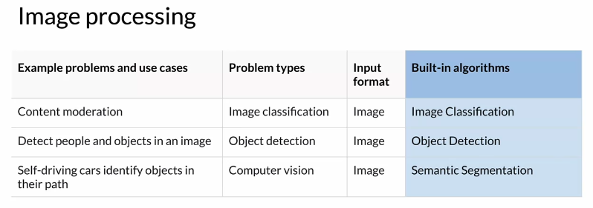
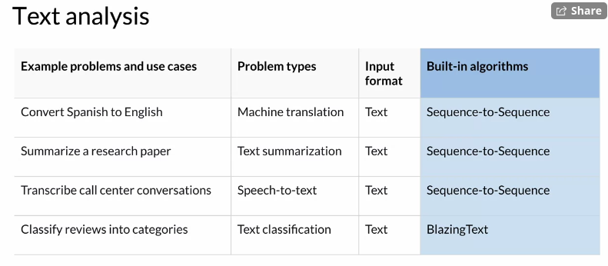

Text analysis

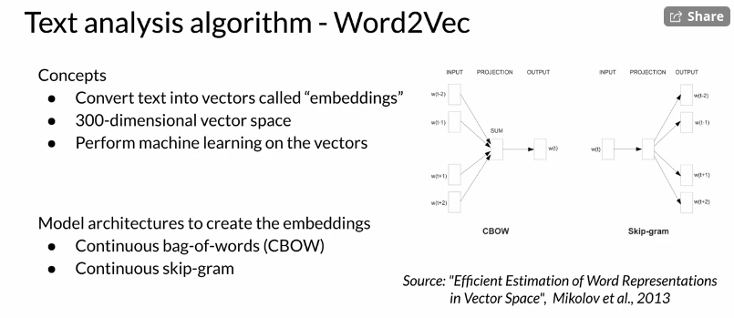
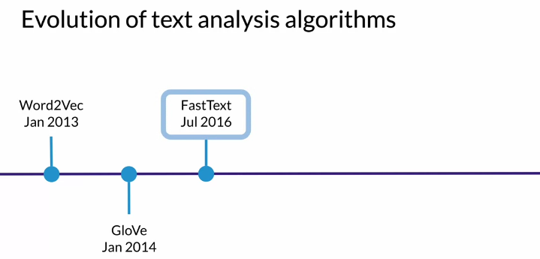
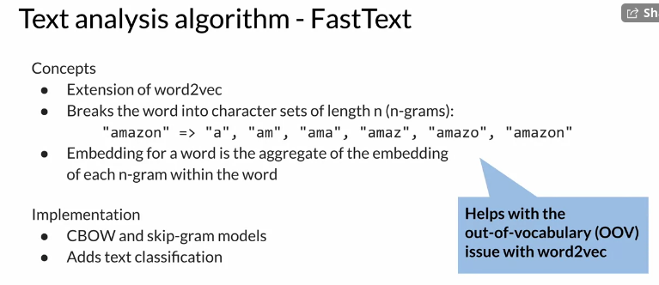
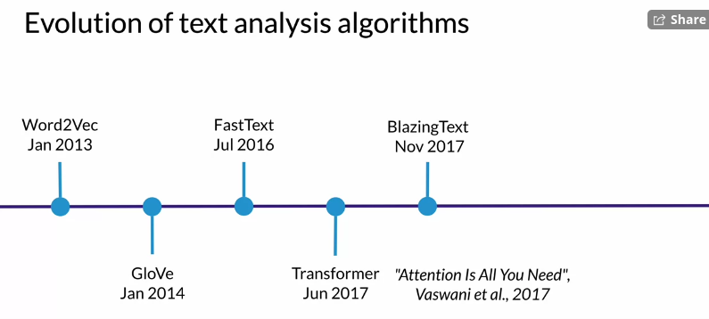

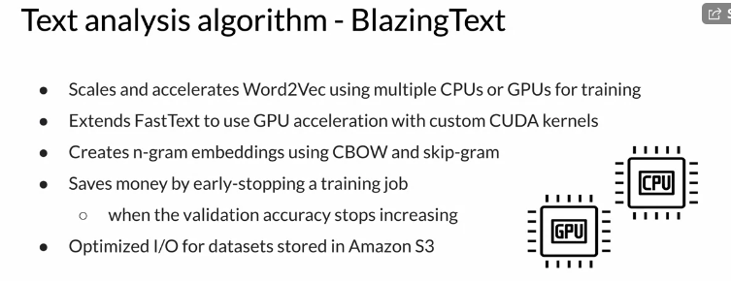
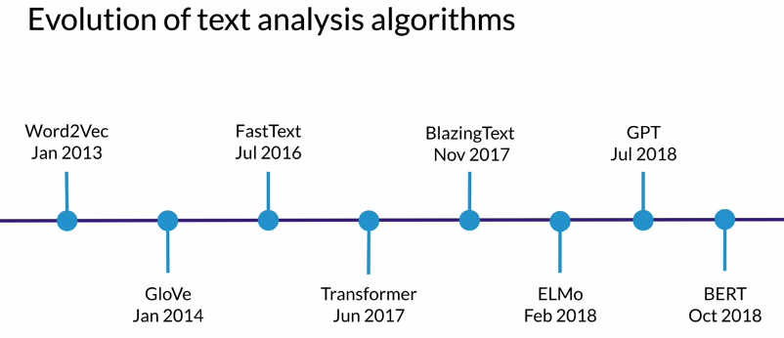

Train a text classifier

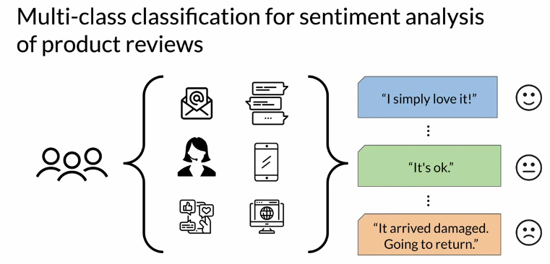
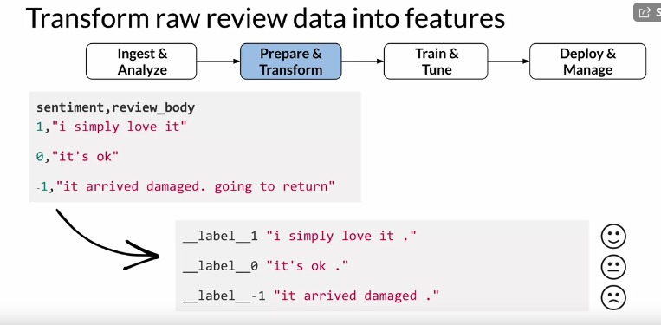
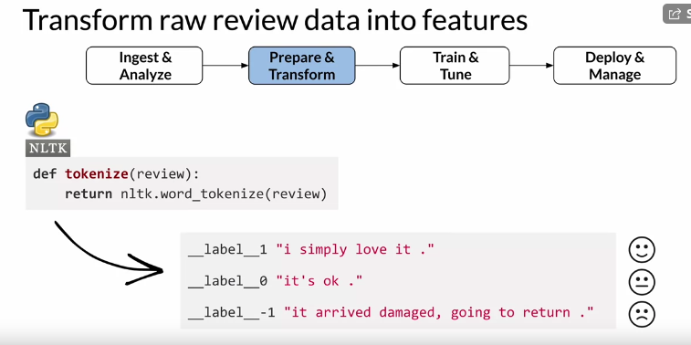
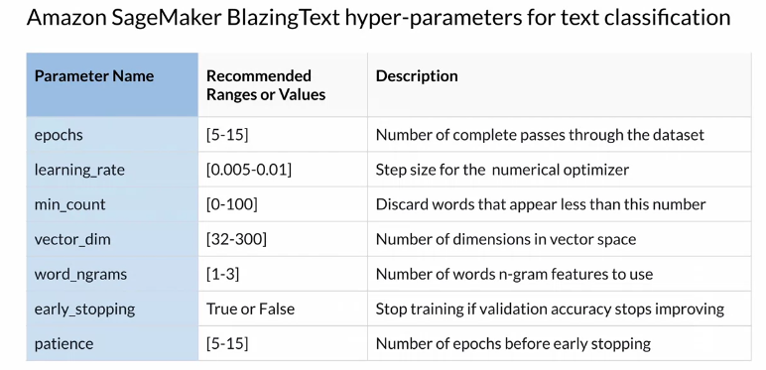
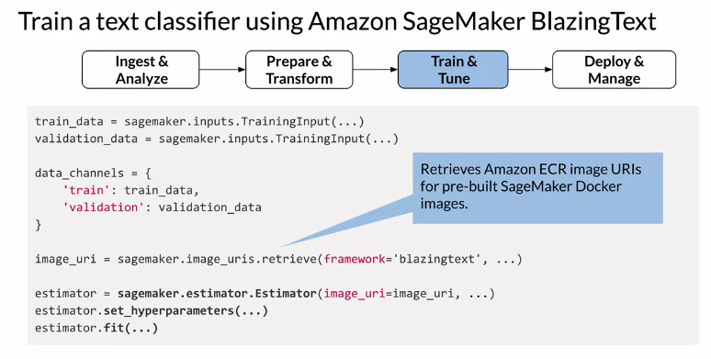
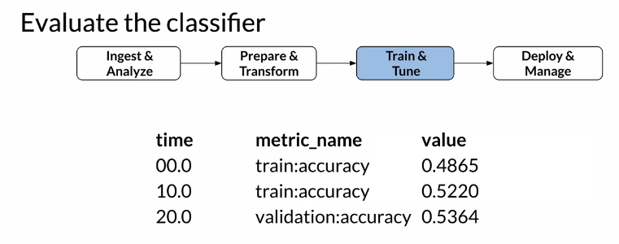

Deploy the text classifier

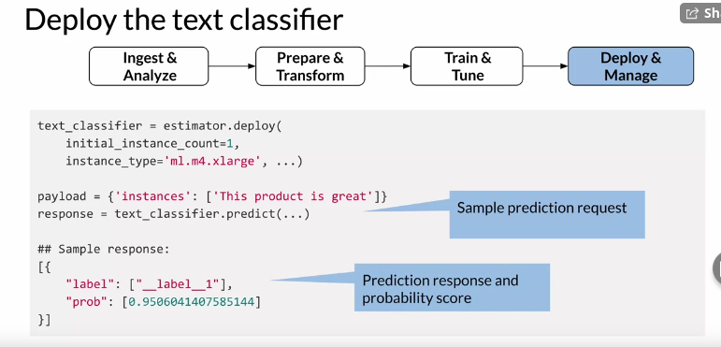

Additional reading material

If you wish to dive more deeply into the topics covered this week, feel free to check out these optional references. (You won’t have to read these to complete this week’s practice quizzes.)
- Word2Vec algorithm
- GloVe algorithm
- FastText algorithm
- Transformer architecture, "Attention Is All You Need"
- BlazingText algorithm
- ELMo algorithm
- GPT model architecture
- BERT model architecture
- Built-in algorithms
- Amazon SageMaker BlazingText

Course 1 Optional References

If you wish to dive more deeply into the topics covered this week, feel free to check out these optional references.

Week 1 Explore the Use Case and Analyze the Dataset:
- AWS Data Wrangler
- AWS Glue
- Amazon Athena
- Matplotlib
- Seaborn
- Pandas
- Numpy

Week 2 Data Bias and Feature Importance:
- Measure Pretraining Bias - Amazon SageMaker
- SHAP

Week 3 Automated Machine Learning:
- Amazon SageMaker Autopilot

Week 4 Built-in algorithms:
- Elastic Machine Learning Algorithms in Amazon SageMaker
- Word2Vec algorithm
- GloVe algorithm
- FastText algorithm
- Transformer architecture, "Attention Is All You Need"
- BlazingText algorithm
- ELMo algorithm
- GPT model architecture
- BERT model architecture
- Built-in algorithms
- Amazon SageMaker BlazingText

